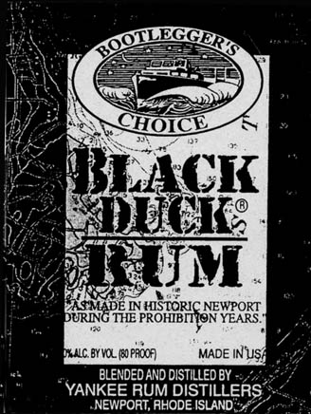
Black Duck Regatta
for
Classic Yachts

Saturday, June 28
Sunday, June 29

Newport, RI
Welcome...

We the producers of Black Duck Rum, in the interest of promoting competition for traditional wooden sailing yachts and a chance to socialize along Newport’s beautiful historic waterfront, host a weekend of racing on Narragansett Bay’s east passage overlooking Newport and Jamestown harbors to celebrate the tradition of racing classic wooden boats.

Eligibility

Wooden auxiliary sailing yachts
Traditionally constructed
Single hull
Designed and built before 1965
Minimum hull length of 28 feet

Skippers meeting

Friday Night - 7:30 PM
Ann Street Pier

Complimentary high
octane Rum Runners will be served; race instructions and other information will also be given out.

Racing will start both days at 1:00p.m., approximately ½ mile south of the Newport Bridge on the Jamestown side of the bay.

.

Trophies
Awards for 1st, 2nd, & 3rd
First to finish in gen’l fleet
Hereshoff “S” Class fleet
The race committee may
also award additional
trophies at their discretion.

awards party
Dinner & drinks served
Sunday -- 6:30pm - 9:00pm
Sailing attire
64 Washinton Street

Party courtesy of Jed Pearsall and Bill Doyle at their home on the Point. [Located on the water side of the street, it is taupe colored and is the only house with double black doors. The party takes place around back / facing the water.]

Entrance Fee
$1.00 per foot - LOA
Pay when you arrive

Registration
-- Any of the below ---
Mail enclosed form
Online -- www.NY30.org
e-mail Bill@performanceresearch.com
Call -- Tyler (401) 848-0111
Call -- Don (401) 849-3033

